Star Wars is a much beloved franchise. Some characters and plots however are more beloved than others by the fan base. A researcher decided to conduct a quick social media poll on the level of agreement with a number of Star Wars opinions known to have varying levels of acceptance or incredulity to die-hard fans. She was particularly interested in whether people are likely to hold multiple unpopular beliefs and so decided to run some correlations to investigate the strength of relationship between four Star Wars opinions. A total of 100 survey respondents rated their agreement with these beliefs on a 5-point scale where 1 is strongly disagree and 5 is strongly agree.

The Star Wars opinions rated were:
- Jar Jar Binks is awesome.
- The Kylo Ren and Rey romance makes sense.
- Han and Chewie rock.
- Boba Fett is over-rated.

Step 1 – Taking a look at the data.
Our four variables have been specified as ordinal variables in Measure type. The anchor points of the Likert scale (1 = strongly disagree, 5 = strongly agree) have also been entered

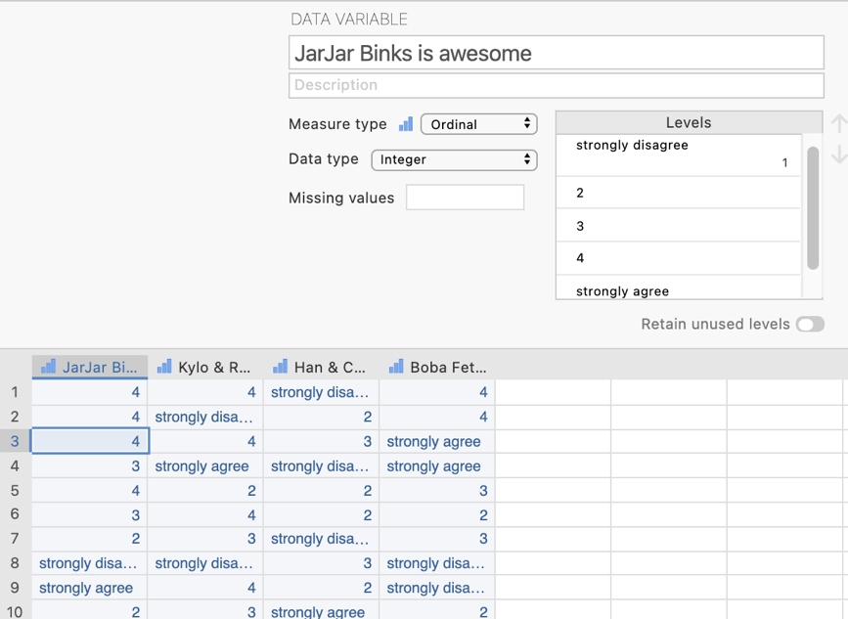
In the data spreadsheet are four columns of data representing the agreement ratings given to each of the four Star Wars opinions. Each row represents a person who has rated each of the four opinions.

Step 2 – Navigating to the correlation analysis menu.

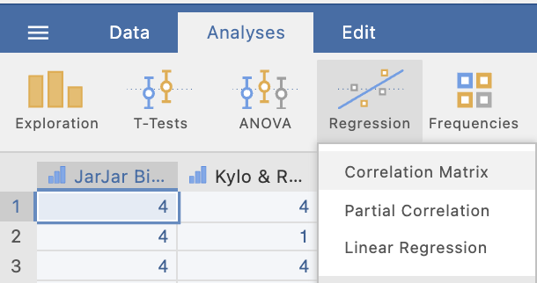
On the Analyses tab select the Regression menu, then select Correlation Matrix.

Step 3 – Selecting analysis options

When you first select Correlation Matrix the following screen will appear. The analysis options appear on the left and the empty results appears on the right, ready to update as you select the analysis options.

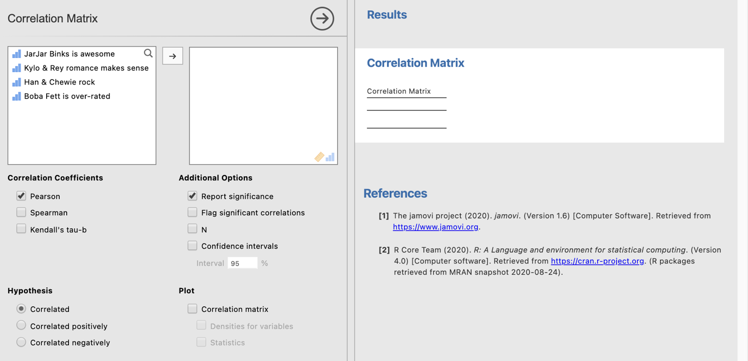

In order to obtain our correlations results we need to shift our variables across from the left hand box to the right hand box in the analysis options panel.

We would need to shift a minimum of two variables across to obtain a correlation. In this case we will shift all four variables across to obtain correlations between all four of our Star Wars opinions.

You’ll notice that as a default Pearson’s correlation coefficients are selected. “Report significance” is also selected under Additional Options. This will provide us our p values to evaluate the significance of each individual correlation coefficient.

Having moved our four variables across to the right side box we get the following default output. We have a correlation matrix showing how agreement levels with each of our four Star Wars opinions correlate with each other.
A correlation matrix provides us with a grid like table that sets out how each variable in the table or matrix correlates with the others.
Circled above is the Pearson’s correlation coefficient and associated p value for the correlation between agreement that Jar Jar Binks is awesome and that the Kylo Ren and Rey romance makes sense. The correlation coefficient is .43 indicating a moderate positive correlation between agreement with the two opinions. The associated p value is reported as <.00001. Given that our p value is less than .05 we reject the null hypothesis that there is no relationship between these two opinions and conclude that the two opinions are significantly positively associated.

There are some extra options we can explore here that can ease our interpretation of the results as well as provide us with some cool visuals. Let’s take a look.
Firstly under Additional Options we could ask for a number of things which will flesh out our correlation matrix.
- We can ask to flag significant correlations which will use the asterisk system to denote correlations significant at p < .05, p < .01 and p < .001 as per APA formatting convention.
- We can also ask for the sample size or N associated with each correlation coefficient which can become relevant if we have some missing data on some variables.
- Finally we can ask for 95% confidence intervals around our correlation coefficients.
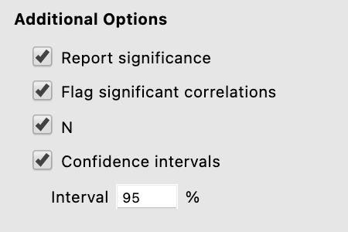

Our correlation matrix now looks much fuller with all these extra details. The flagging of significant correlation coefficients can be very helpful to orient your examination of the correlation matrix. Particularly so when you have a large number of variables in the mix.

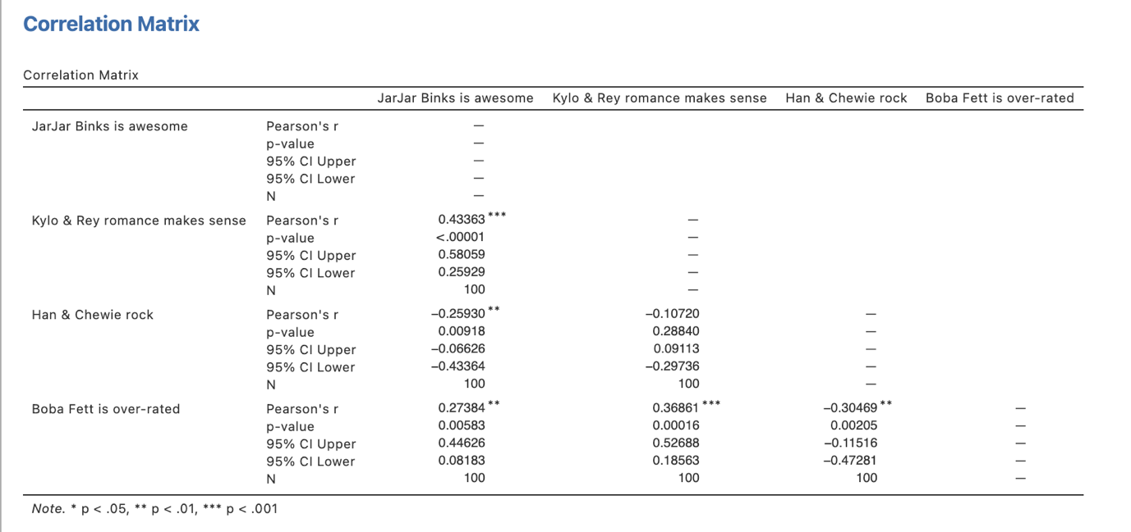

You can also ask for a correlation matrix that incorporates scatterplots for each relationship.

Asking for a Correlation matrix and statistics under the Plot heading provides you with a correlation matrix with scatterplots below the diagonal and the correlation coefficients with significances flagged above the diagonal.
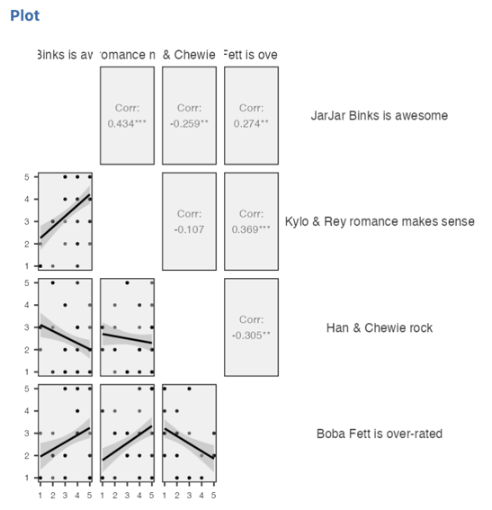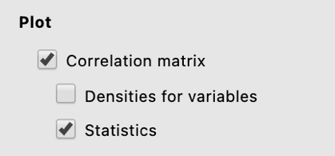
Step 4 – Finding the components for reporting.

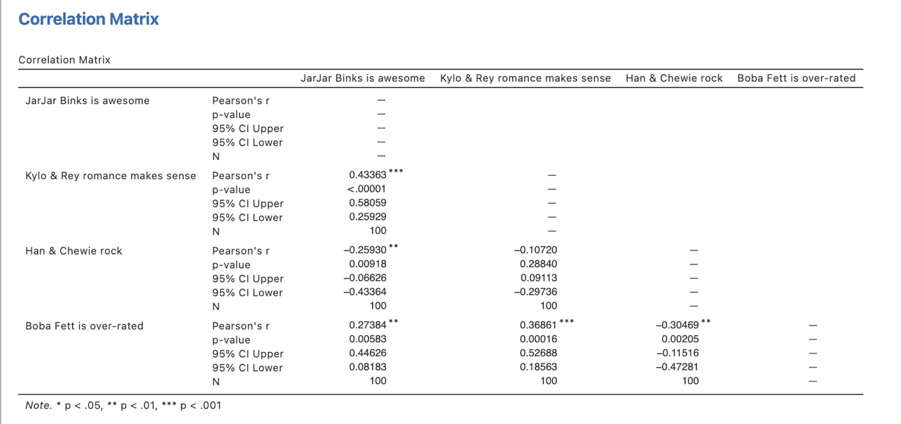
Here we have all the information to write up a detailed results paragraph. Let’s pull the components out and see where they fit into the write up.

We have four key components here we could report.
- The significance test – the p value for the t test that evaluates the significance of each individual correlation coefficient.
- The degrees of freedom are not specifically reported here though they can be figured out from the N. Degrees of freedom for correlations are N – 2.
- Correlation coefficients which also happen to be effect sizes.
- 95% confidence intervals around our correlation coefficients which give us an indication of the interval within which we expect the population correlation coefficient would fall. Note that we don’t often report these when we have a large number of correlation coefficients to report as it becomes unwieldly.

The Write Ups:

- An example single correlation coefficient write up complete with confidence intervals

A sample of 100 respondents rated their level of agreement with the generally unpopular opinions that Jar Jar Binks is awesome and the Kylo Ren and Rey romance makes sense within the Star Wars franchise. A Pearson’s correlation coefficient was computed and revealed a significant moderate positive relationship between agreement with the two opinions suggesting they are more than likely to be jointly held, r(98) = .433, p < .001, 95% CI [.26, .58].

- An example summary write up of all relationships presented in the correlation matrix (without confidence intervals.

A sample of 100 respondents rated their level of agreement with several unpopular opinions (Jar Jar Binks is awesome, the Kylo Ren and Rey romance makes sense and Boba Fett is over-rated) and a generally accepted opinion (Han and Chewie rock) within the Star Wars franchise. Agreement with the generally accepted opinion that Han and Chewie rock was found to negatively correlate with the three unpopular opinions, with the opinion that Boba Fett is over-rated correlating most strongly with a significant moderate correlation, r(98) = -.30, p = .002, followed by the opinion that Jar Jar Binks is awesome, r(98) = -.26, p = .009. The three generally unpopular opinions all correlated significantly with each other and were found to be positively related, suggesting they are likely to be jointly held. The strongest correlation was found between agreement with the opinions that the Kylo Ren and Rey romance makes sense and that Jar Jar Binks is awesome, r(98) = .43, p <.001, while the weakest was the correlation between the Kylo Ren and Rey romance makes sense opinion and the opinion that Boba Fett is over-rated, r(98) = .27, p = .006. Overall it seems that the unpopular opinions tend to be jointly held while those who share a popular opinion are unlikely to also hold the unpopular opinions in relation to the Star Wars franchise.

Created by Janine Lurie in consultation with the Statistics Working Group within the School of Psychology, University of Queensland

Based on jamovi v.1.8.4

The Statistics Working Group was formed in November 2020 to review the use of statistical packages in teaching across the core undergraduate statistics unit. The working group is led by Winnifred Louis and Philip Grove, with contributions from Timothy Ballard, Stefanie Becker, Jo Brown, Jenny Burt, Nathan Evans, Mark Horswill, David Sewell, Eric Vanman, Bill von Hippel, Courtney von Hippel, Zoe Walter, and Brendan Zietsch.
The jamovi project (2020). jamovi (Version 1.8.4) [Computer Software]. Retrieved from https://www.jamovi.org

