According to data collated in 2020, Instagram users spend an average of 53 minutes a day on the platform. A statistics tutor decided to survey her class of 15 students about the time they spend on Instagram to see how this compared to this average. Her students wrote the estimated minutes per day they spend on Instagram. She hypothesised that her class would spend significantly longer per day on Instagram than this platform-wide average.

Step 1 – Taking a look at the data.

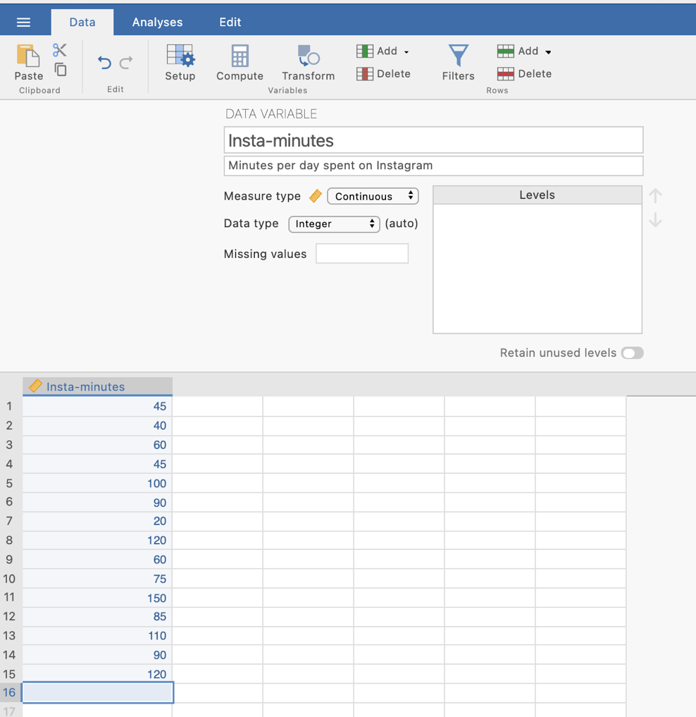
In the data spreadsheet are the 15 scores on the Insta-minutes variable obtained from the 15 students in the statistics class. These have been entered as a single column of data with each row representing an individual student.
Our variable is labelled “Insta-minutes” and provided a description of the variable.
The variable has been specified as continuous variable in Measure type.

Step 2 – Navigating to the One/Single Sample t-test analysis menu.
On the Analyses tab select the T-tests menu, then select One Sample T-Test.
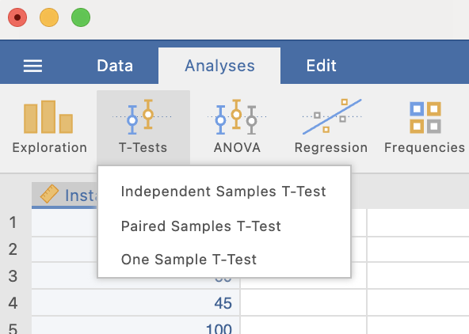

Step 3 – Selecting analysis options

When you first select the One Sample T-Test the following screen will appear. The analysis options appear on the left and the empty results appears on the right, ready to update as you select the analysis options.

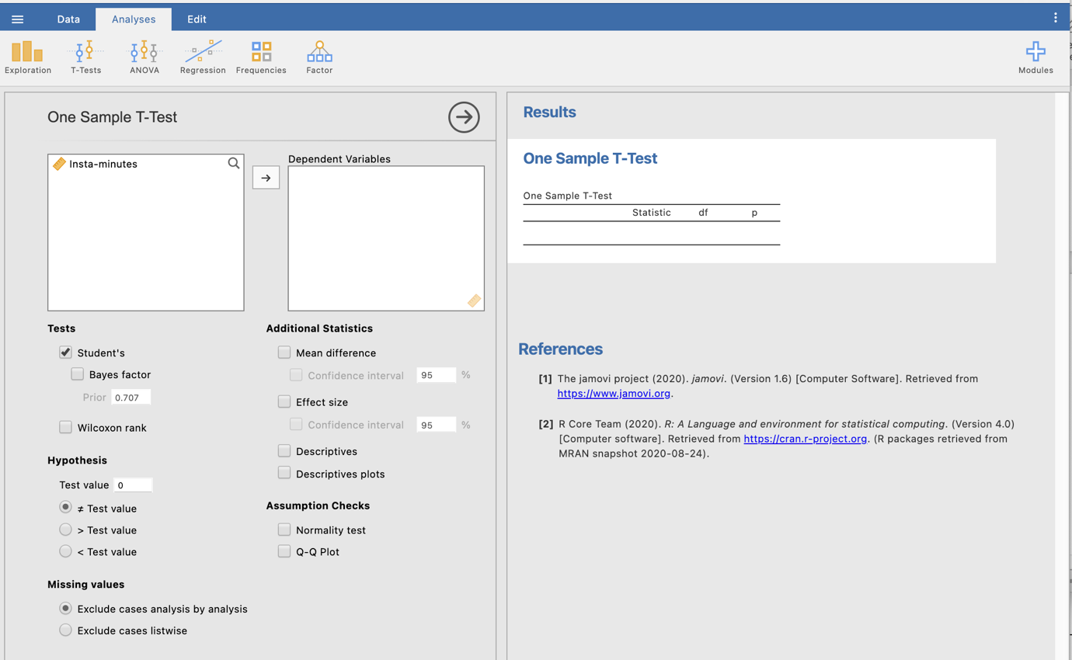

There are two key things we have to do to run our one sample t-test.
The first is to move our Insta-minutes variable across to the Dependent Variables box. This tells jamovi to use this variable in the analysis as our dependent variable.
The second is to tell jamovi what our “test value” is. The test value is another way of referring to the population mean we want to use as a comparison point. We are testing whether our sample mean differs significantly from this mean. In our example the test value is 53 minutes of Instagram time.

NB – The > test value and < test value options would provide one-tailed t-test results, but we will stick with a two-tailed approach which does not specify a result direction.

Doing these two things provides us with some bare bones results for our one sample t-test.

Here we are given several pieces of information as a default. The “Statistic” value is the t score we would calculate if we calculated it by hand. We are also given the degrees of freedom (14, given that we have a sample of 15 and df = N – 1).
Our p value here is .00993. This value is less than .05 so we will reject the null hypothesis that there is no difference in the amount of minutes spent on Instagram by the statistics students and the platform-wide average.

Let’s look at the extra options we could choose from to help flesh out the information we can report.

Additional statistics that are helpful to ask for are descriptives and the mean difference to help you describe the pattern of results. The effect size helps you describe the magnitude of the result you have obtained. You can also ask for confidence intervals around the effect size or the mean difference. We’ll ask for these for our mean difference in this instance.

Step 4 – Finding the components for reporting.
Here we have all the information to write up a detailed results paragraph. Let’s pull the components out and see where they fit into the write up.

We have four key components here.
- The t score, df and p value – the t-test result
- An effect size in the form of Cohen’s d.
- The mean difference and associated confidence interval – the difference between our sample mean and the population mean/test score.
- Descriptives for our data – mean and standard deviation are of most use here.

The Write Up:

Students in the statistics class spend 27.67 minutes more per day (95% CI [7.76, 47.58]) on Instagram (M = 80.67 minutes, SD = 35.95 minutes) than the average of 53 minutes per day spent by all Instagram users in 2020. These 27.67 additional minutes of Instagram time represent a significant difference from the platform wide average, with a large effect size, t (14) = 2.98, p = .010, d = 0.77.

Created by Janine Lurie in consultation with the Statistics Working Group within the School of Psychology, University of Queensland

Based on jamovi v.1.8.4

The Statistics Working Group was formed in November 2020 to review the use of statistical packages in teaching across the core undergraduate statistics units. The working group is led by Winnifred Louis and Philip Grove, with contributions from Timothy Ballard, Stefanie Becker, Jo Brown, Jenny Burt, Nathan Evans, Mark Horswill, David Sewell, Eric Vanman, Bill von Hippel, Courtney von Hippel, Zoe Walter, and Brendan Zietsch.
The jamovi project (2021). jamovi (Version 1.8.4) [Computer Software]. Retrieved from https://www.jamovi.org

