Outlander is an historical/science fiction/time travel television series about a woman who is transported back in time from 1945 to 1743 in Scotland and the lives she leads in both time periods. The television series is based on a book series by author Diana Gabaldon. Let’s pretend that executives at Netflix were debating whether to make the next season available all at once, or whether to continue with their existing plan of releasing episodes one at a time. They commissioned a researcher to conduct a study into whether enjoyment of the series is affected by the way in which viewers choose to watch the show. The executives were interested in whether viewers seemed to enjoy the show more if they were able to stream all the episodes all at once, and hence choose to binge-watch the show, or whether releasing episodes one at a time, hence prolonging anticipation, was associated with greater enjoyment. The researcher recruited 30 people who had not watched Outlander before and randomly allocated them into three separate groups. One group were only allowed to watch one episode per week. The second group watched several episodes in one sitting but ultimately got through the season in multiple sittings. The third and final group watched the entire season in one sitting.

Step 1 – Taking a look at the data.

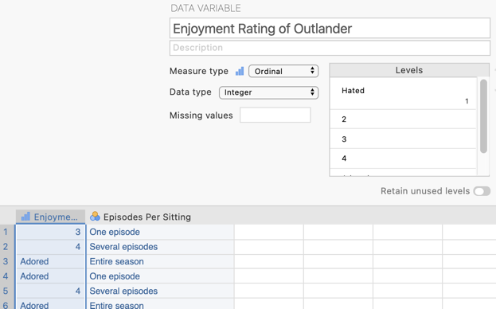
Our dependent variable “Enjoyment Rating of Outlander” has been specified as an ordinal variable in Measure type and is the first column of data. This variable is rated on a 5-point Likert scale from 1 “Hated” to 5 “Adored.”
N.B., While a Likert scale is technically ordinal, in psychology we commonly treat Likert scale variables as continuous for analysis purposes. In an ANOVA our dependent variable should be continuous.

In the second column of our data spreadsheet we have a variable “Episodes Per Sitting” which tells jamovi which group the participants are in. The measure type has been set as ordinal. There are three groups as created by the researcher. In an ANOVA our independent variable can be ordinal or nominal.
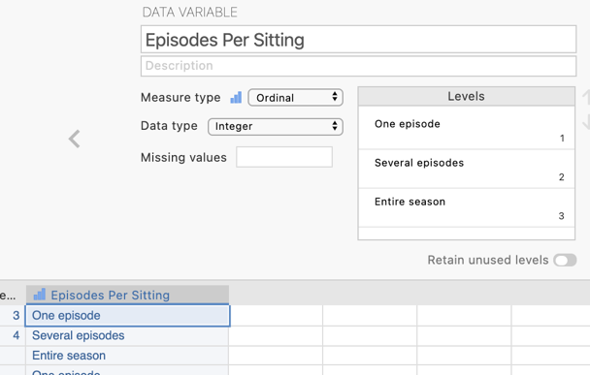

Step 2 – Obtaining means and standard deviations on our dependent variable for each group

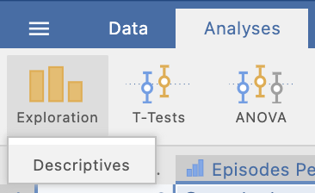
On the Analyses tab select the Exploration menu, then select Descriptives.

Move the dependent variable, Enjoyment Rating of Outlander to the “Variables” box

and the independent variable Episodes Per Sitting to “Split by”

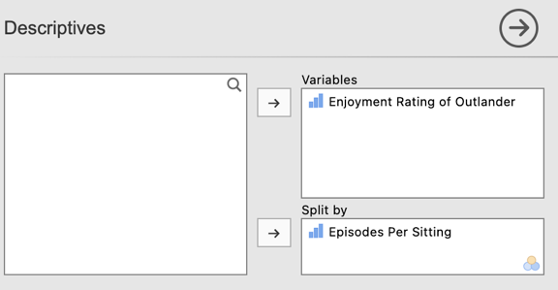

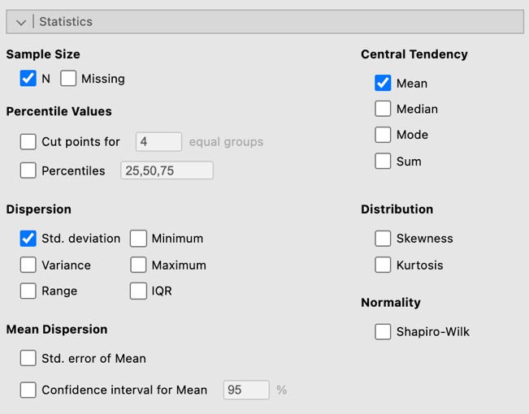
Under the “Statistics” drop down menu the three things we require are the Sample Size N, the mean as our Central Tendency measure and the standard deviation as our measure of dispersion. Untick all additional options and ensure just these three are selected to keep our output focussed on what we need.
Here we have the means and standard deviations (and n for each group) that form the basis of our ANOVA. From a quick look at these means it looks like enjoyment ratings increase the more episodes are watched consecutively. But let’s run our ANOVA to see if this pattern yields any significant differences
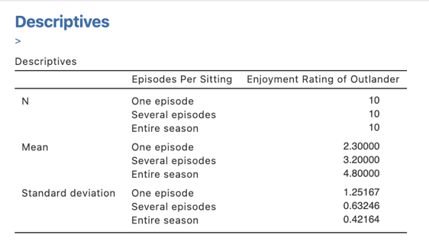

Step 3 – Navigating to the ANOVA analysis menu.
On the Analyses tab select the ANOVA menu, then select ANOVA.

N.B., You will see there is also a One-Way ANOVA menu option. This version of the ANOVA analysis does not have all the options we want so we are not going to use this method, so we will run our analysis via “ANOVA” rather than “One-Way ANOVA”

Step 4 – Selecting analysis options to get the output we need

The first thing we will do is specify our dependent and independent variables.

We need to move Enjoyment Rating of Outlander to the Dependent Variables box and Episodes Per Sitting to the Fixed Factors box. This tells jamovi we want to compare enjoyment rating means across the three viewing mode groups.

Moving our IV and DV into place gives us our initial ANOVA result.
In our ANOVA table we have the components of the calculations that help us arrive at our F statistic (namely the SS_{treat} and SSerror and their associated dfs, which lead us to our MS_{treat} which we divide by the MSerror to get our F statistic.

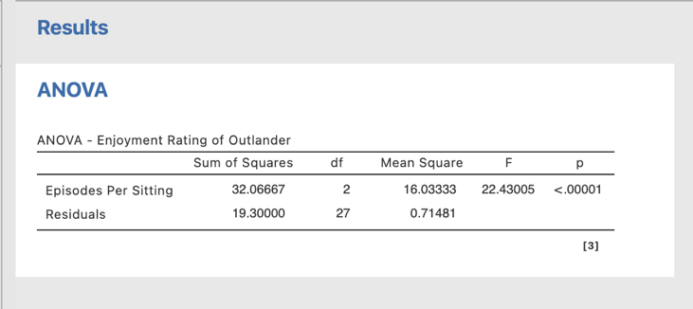
Our p value here is <.00001. This value is less than .05 so we will reject the null hypothesis that there is no difference in enjoyment ratings of Outlander based on viewing pattern.

We can also ask for an effect size for our ANOVA under where we specify our variables for the analysis.
You can select between $η$², $η_{p}^{2}$ and $ω$². We’ll ask for $η$² and $ω$² so we can compare them.

N.B., $η_{p}^{2}$ is only relevant for factorial ANOVAs with two or more independent variables/factors.
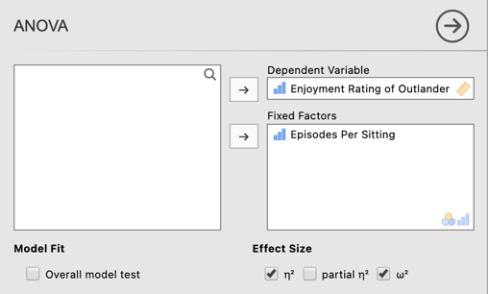
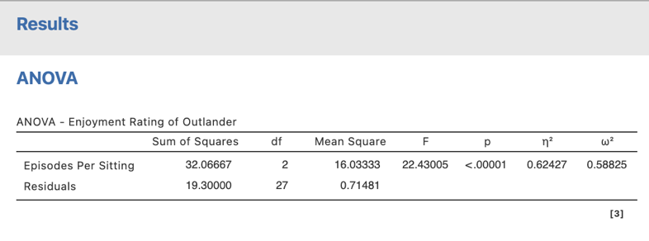
You can see that we now have the two effect sizes we requested added into our ANOVA model table. As expected the $ω$² is lower than the $η$² as it is adjusted downwards as an estimate of the population effect size.

We need to ask for some additional statistics and visual aids to add to our interpretation and write up of the results. There are many options organised under five tabs as can be seen below. For our purposes we only need to use the Post Hoc Tests and the Estimated Marginal Means tabs.

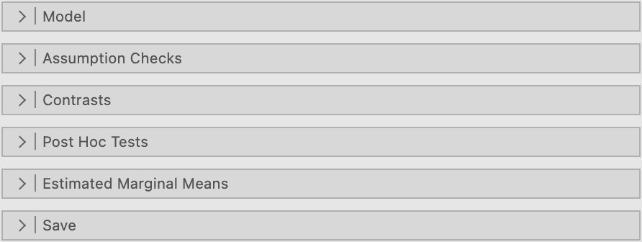

As we have a significant omnibus F test we need to conduct post hoc tests to uncover where the significant differences are.
To do this in the Post Hoc Tests tab we need to move our IV, Episodes Per Sitting from the box on the left to the box on the right. Under corrections we’ll select “No correction.” Finally under Effect Size we’ll ask for Cohen’s d for each of our post hoc pairwise comparisons and associated confidence intervals. The output generated for these can be seen below
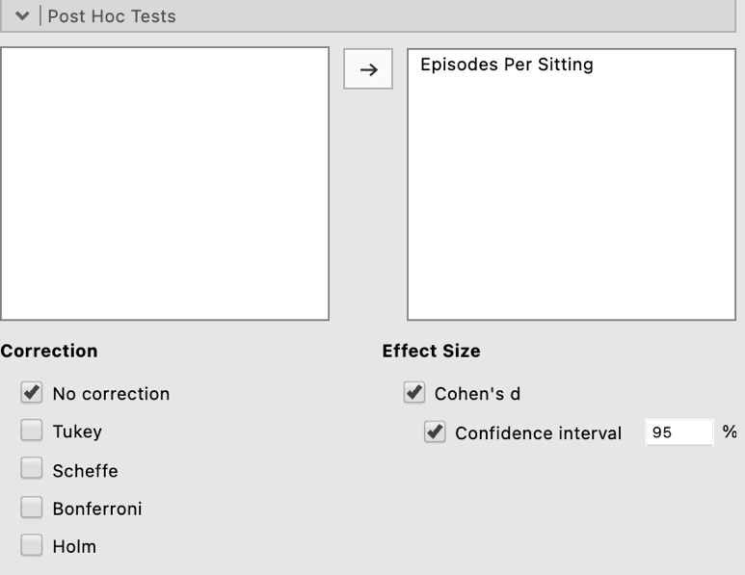

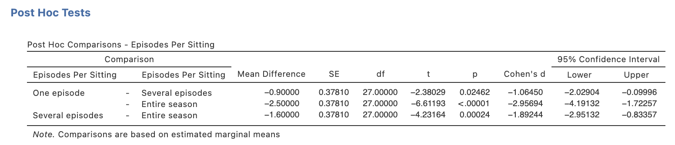
The Estimated Marginal Means tab gives us options to obtain a plot to illustrate our results.

Firstly we need to move our IV, Episodes Per Sitting, under the “Term 1” heading in the Marginal Means box on the right hand side like this:

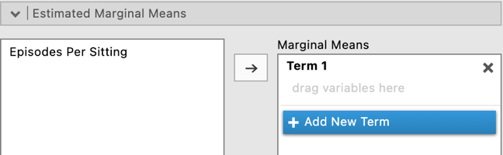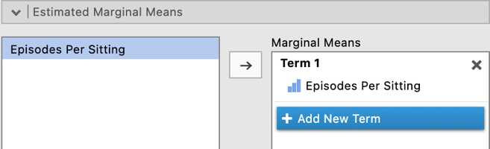

As a default “Marginal means plots” will be selected and create the plot on the left here. Note that error bars based on 95% confidence intervals will be created on the plot. However you can change these to standard errors or choose to remove them all together in the drop down list.

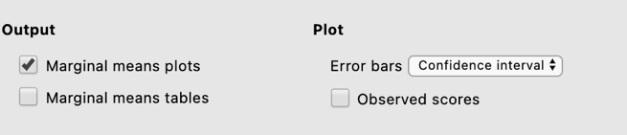
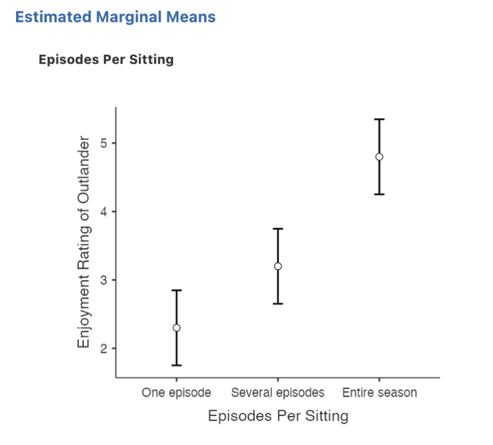

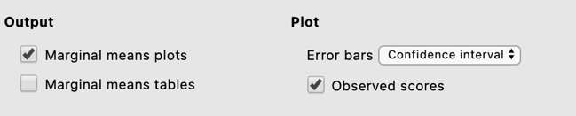
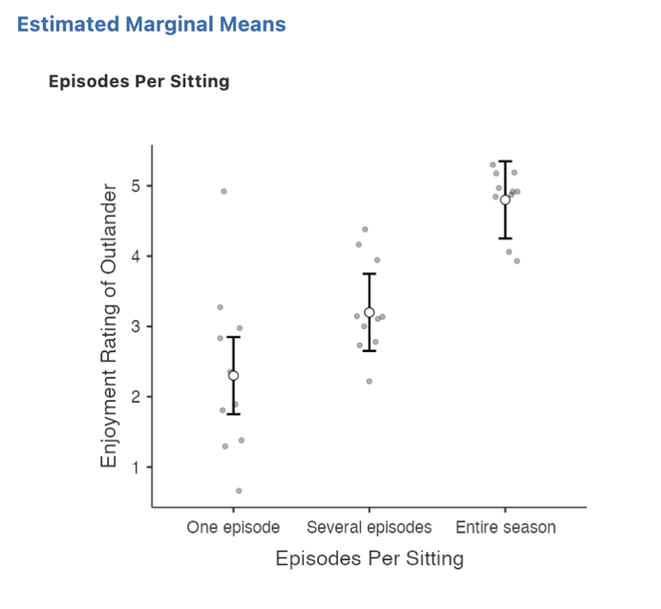
If you tick “Observed scores” your plot will also include all your participants scores so that you can visualise the spread of scores around the group means and error bars.

Step 5a – Finding the components for reporting the omnibus results

We’ve now run all the things we need to write up our one-way between groups ANOVA results, complete with post hoc pairwise comparisons. Let’s pull it all together.

Firstly, let’s report our omnibus results.

The components we obtain here are:
- The F statistic, dfs and p value – the omnibus ANOVA result
- An effect size in the form of$η$²

The Write Up (Part 1):

Thirty participants were randomly allocated to three groups to watch the first season of the television series Outlander, one episode per week, several episodes over multiple sittings, or all episodes in one sitting. A one-way between groups ANOVA found that enjoyment ratings of the television series differed significantly across viewing modes, F(2,27) = 22.43, p <.001, $η$² = 0.62.

Tip: In APA format we report our p value to three decimal places. Where our p value would round to .000 we report this as p <.001 and not p = .000 which would imply our p value is equal to zero when it is not.

Step 5b – Finding the components for reporting the post hoc comparisons.

The next stage of the write-up is to present the post hoc comparisons that reveal where the significant differences in group means specifically fall. We’ll use the descriptives table we obtained at the start as well as the post hoc comparisons table to put this part of our write up together.

The elements needed for the post hoc section of our write up are:

- Post hoc comparison results – to determine which group means are significant from each other. It is sufficient to report the p value for this.
- An effect size for each post hoc comparison in the form of Cohen’s d and associated 95% confidence intervals.
- Means and standard deviations – to help describe the pattern of these differences.

The continuation of the write up could go as follows:

The Write Up (Part 2):

Unadjusted post hoc comparisons revealed significant differences between each viewing mode with enjoyment ratings when the entire season was watched in one sitting (M = 4.80, SD = 0.42), significantly higher than when viewed in several multi-episode sittings (M = 3.20, SD = 0.63, p < .001, d = 1.89, 95% CI [0.83, 2.95]) which in turn yielded significantly higher enjoyment ratings than viewing one episode at a time (M = 2.30, SD = 1.25, p = .025, d = 1.06, 95% CI [0.10, 2.03]).

Potential addition of plot:

You could also add the plot we obtained to help illustrate the pattern of results. You might add a sentence like the following if you choose to include the plot:

Figure 1 below demonstrates these group differences visually.

Figure 1

Differences in Enjoyment Ratings of the Outlander Television Series by Viewing Mode

Note. Error bars represent 95% confidence intervals.

Created by Janine Lurie in consultation with the Statistics Working Group within the School of Psychology, University of Queensland

Based on jamovi v.1.8.4

Further information about the Outlander television and book series can be found at https://en.wikipedia.org/wiki/Outlander_(TV_series)#Production.
The Statistics Working Group was formed in November 2020 to review the use of statistical packages in teaching across the core undergraduate statistics unit. The working group is led by Winnifred Louis and Philip Grove, with contributions from Timothy Ballard, Stefanie Becker, Jo Brown, Jenny Burt, Nathan Evans, Mark Horswill, David Sewell, Eric Vanman, Bill von Hippel, Courtney von Hippel, Zoe Walter, and Brendan Zietsch.
The jamovi project (2021). jamovi (Version 1.8.4) [Computer Software]. Retrieved from https://www.jamovi.org

