A statistics tutor surveyed her class of 15 students about the time they spend on Instagram. Her students wrote the estimated minutes per day they spend on Instagram. When the data was collected it was revealed that the students spent an average of 80.67 minutes a day on Instagram. A robust debate ensued in the class and the students decided they would attempt to reduce the time they spent on Instagram. Their tutor said “Perfect! We’ll collect more data next week and test whether you have managed to significantly reduce your Insta-minutes.” When the data had been collected in the second week and the tutor looked at the distributions they looked a bit leptokurtic. She decided they should be explored using a non-parametric test rather than the dependent means or paired samples t-test she had planned. The non-parametric equivalent of a dependent means t-test is a Wilcoxon’s signed rank test.

Step 1 – Taking a look at the data.
Our variables are labelled “Insta-minutes time 1” and “Insta-minutes time 2”.
The variables have been specified as a continuous variable in Measure type.
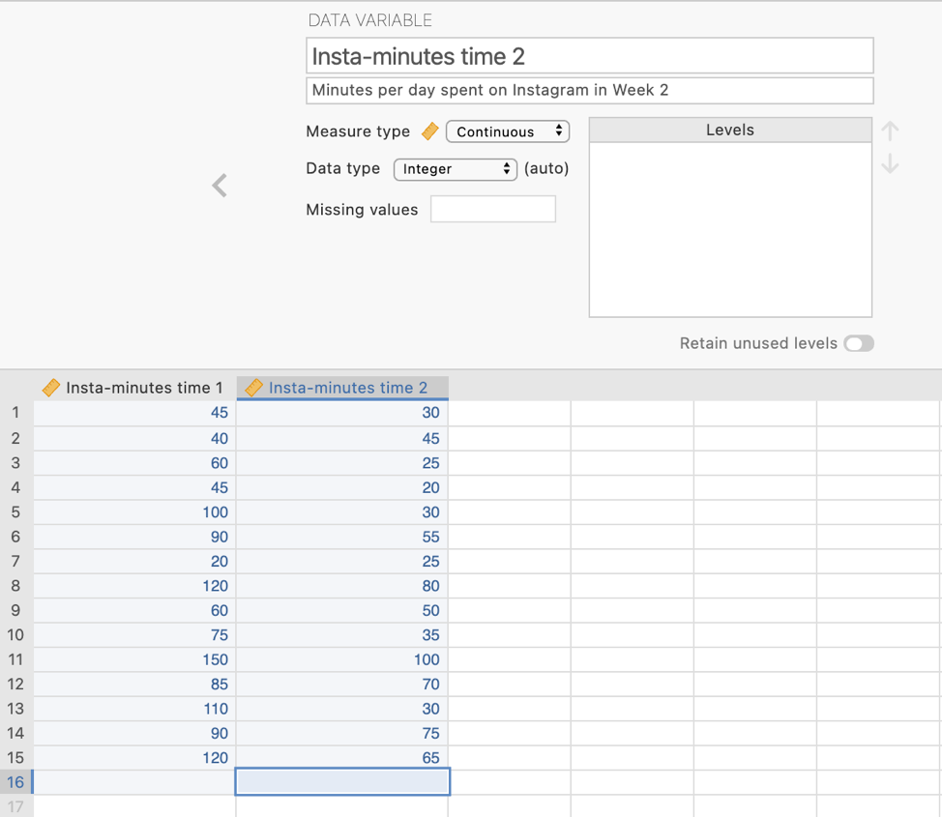
In the data spreadsheet are the 30 scores on the Insta-minutes variables obtained from the 15 students in the statistics class. There are two columns, one for Time 1 scores and one for Time 2 scores.

Step 2 – Navigating to the Paired Samples t-test analysis menu.
On the Analyses tab select the T-tests menu, then select Paired Samples T-Test. The Wilcoxon signed rank test is a non-parametric equivalent of the paired samples t-test and both are under the same menu.
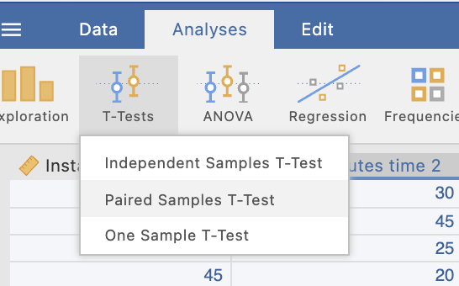
Step 3 – Selecting analysis options

To run our Wilcoxon’s signed rank test we need to move our Time 1 and Time 2 variables across into the “paired variables” box.
You can now see that our two variables appear linked in the paired variables box. This tells jamovi that we want to examine the difference between our Time 1 and Time 2 variables.
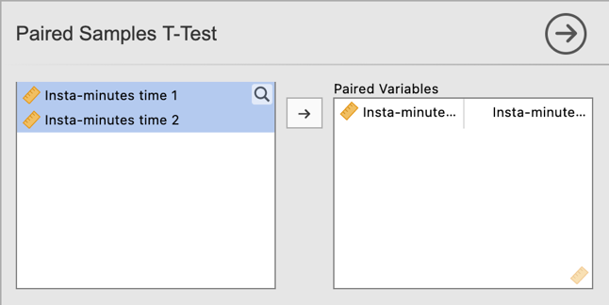

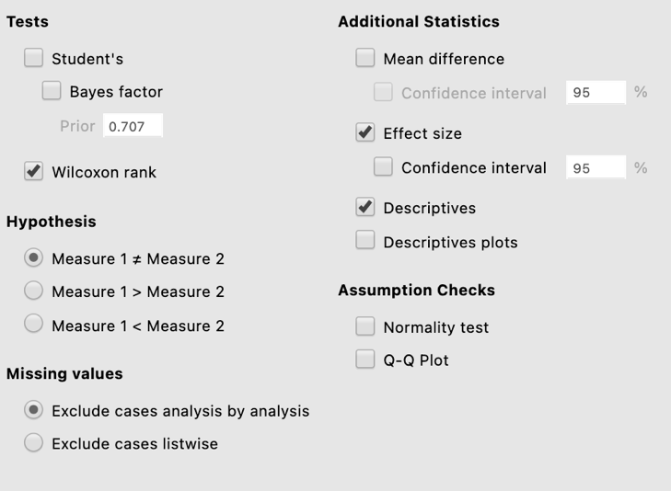
In the analysis options we want to ask for the Wilcoxon rank test under Tests, and Effect Size and Descriptives under Additional Statistics.

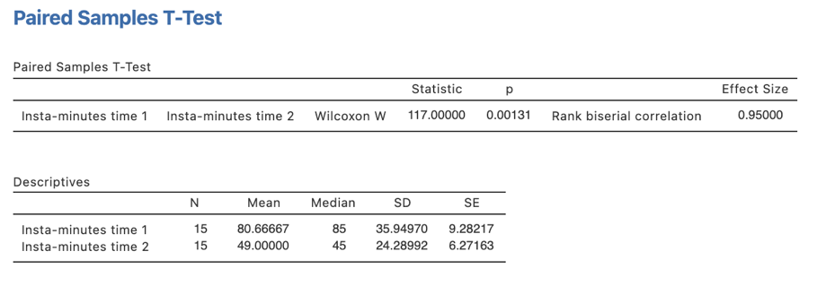
Here we have all the information to write up a detailed results paragraph. Let’s pull the components out and see where they fit into the write up.

Step 4 – Finding the components for reporting.

The key components here are:
- The Wilcoxon’s W and p value – the test result
- An effect size in the form of the rank-biserial correlation, r_{rb}.
- Descriptives for our data – medians in particular are reported here.

The Write Up:

Students in the statistics class reduced the time they spent on Instagram from a median of 85 minutes in week one to 45 minutes in week two. A Wilcoxon’s signed-ranks test revealed this to be a significant decrease in Instagram usage, W = 117.00, p = .001, r_{rb} = .95.

Created by Janine Lurie in consultation with the Statistics Working Group within the School of Psychology, University of Queensland

Based on jamovi v.1.8.4

The Statistics Working Group was formed in November 2020 to review the use of statistical packages in teaching across the core undergraduate statistics unit. The working group is led by Winnifred Louis and Philip Grove, with contributions from Timothy Ballard, Stefanie Becker, Jo Brown, Jenny Burt, Nathan Evans, Mark Horswill, David Sewell, Eric Vanman, Bill von Hippel, Courtney von Hippel, Zoe Walter, and Brendan Zietsch.
The jamovi project (2021). jamovi (Version 1.8.4) [Computer Software]. Retrieved from https://www.jamovi.org

